**Project Description**

The Flight Reservation System (FRS) allows **Travelers** to efficiently find, reserve and book an itinerary of flights to get them to and from their destination. They will be able to search the library of flights to find exactly which ones suit their needs, create an itinerary to see a summary of their trip, and complete the process by submitting payment information and booking the reservation. **Reservation Managers** have administrative privileges within the application and can publish / update flights in the database as well as generate inventory reports.

I’ll be starting off specifying the application by creating a series of use-cases and prioritizing them using the Moscow Method. Throughout the process I’ll use UML to aid in the design of the system. The application will be built in the Java programming language using the Eclipse IDE. I’ll be conducting unit tests using JUnit and building the application using Apache Ant.

**Use Cases**

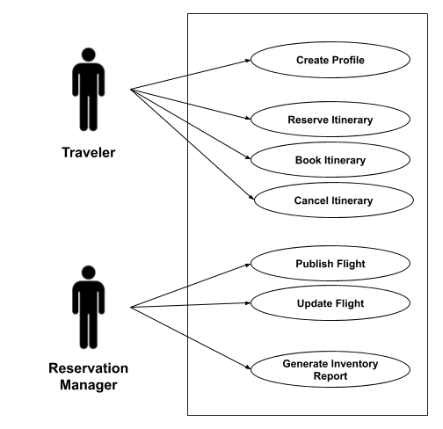

**Use Case Descriptions**

**UC-1: Create Profile**

Actor: Traveler

Description: Customer accesses the flight reservation application and is prompted to provide credentials to log in. They are also given an option to create a new profile if they are a new user. After selecting the create new profile option, they are directed to fill out a form to register. They provide their first and last name, address, username, password, and email address. Optionally, they can also add their credit card information which includes a 16 digit credit card number and 4 digit expiration date. After registration is complete they can now use the specified username and password to log in to the system.

**UC-2: Reserve Itinerary**

Actor: Traveler

Description: Customer searches for available flights by providing dates and times for departure and arrival, the number of passengers, the destination, and designates whether they want a one-way or round-trip flight. They are shown a list of available flights with departure / arrival time information and cost. After selecting one to be reserved, it shows up in their list of upcoming flights.

**UC-3: Book Itinerary**

Actor: Traveler

Description: After reserving an itinerary a customer can book it by selecting an option from the itinerary page. If payment card information is already attached to their profile that card will be charged. Otherwise, they are prompted to add payment information and authorize the charge. The itinerary then shows a status as *booked* in their itinerary list.

**UC-4: Cancel Itinerary**

Actor: Traveler

Description: A customer can go to their itinerary list and locate one that they want to cancel. After selecting an option to cancel it, it no longer appears on their itinerary list.

**UC-5: Publish Flight**

Actor: Reservation Manager

Description: The reservation manager logs into the system with admin credentials to access the admin page. After choosing the *Publish Flight* option they are redirected to fill out a form to add a new flight to the database. They enter the following fields to create a new flight: airline code / name, flight number, departure location, departure date / time, arrival location, arrival date / time, cost of business-class ticket and cost of economy-class ticket.

**UC-6: Update Flight**

Actor: Reservation Manager

Description: The reservation manager logs into the system as an admin and on the admin page searches by flight number to locate the desired flight. They are given an option to edit the flight details. After selecting the *Edit Flight* option they are able to edit any of the above-mentioned fields except flight number. They then save their changes and the record is updated.

**UC-7: Generate Inventory Report**

Actor: Reservation Manager

Description: The reservation manager logs in the system as an admin and from the admin page they select an option to generate an inventory report. A report is generated than contains a summary of all flights in the reservation system.

**Use Case Prioritization**

**Must:** UC-5 Publish Flight, UC-1 Create Profile (Login), UC-2 Reserve Itinerary

**Should:**, UC-6 Update Flight, UC-3 Book Itinerary

**Could:** UC-4 Cancel Itinerary

**Won’t:** UC-7 Generate Inventory Report